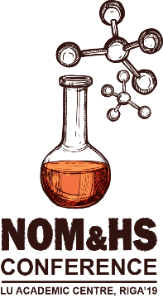 | ABSTRACT SUBMISION FORM
NATURAL ORGANIC MATTER FLOWS AND PROPERTIES: FROM THE THEORY TO APPLICATION
CONFERENCE, LU DAC, RIGA’19

PRESENTING AUTHOR(S):
(Mr, Mrs, Ms), First name, Surname, Position, Scientific Degree, Organization/Department
CO-AUTHORS:
First name, Surname, e-mail and affiliation

PRESENTING AUTHOR(S) INFORMATION
E-MAIL
PHONE:
(with country code)
MAILING ADDRESS:

RELEVANT TOPIC OF THE CONFERENCE:  check the correct item | PREFERRED PARTICIPATION TYPE:  check the correct item
☐ T1: NOM in aquatic and terrestrial systems  ☐ T2: Global change and NOM flows  ☐ T3: Humic substances in Nordic environment  ☐ T4: Interaction of NOM with nutrients and xenobiotica  ☐ T5: Potential of practical application of humic substances: agriculture and technologies | ☐ P1: Oral Presentation  ☐ P2: Poster Presentation  ☐ P3: Participant Only

