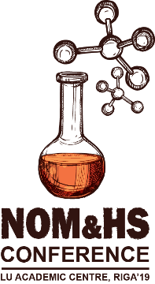 | ABSTRACT SUBMISION FORM
NATURAL ORGANIC MATTER FLOWS AND PROPERTIES: FROM THE THEORY TO APPLICATION
CONFERENCE, LU DAC, RIGA’19

PRESENTING AUTHOR(S):
(Mr, Mrs, Ms), First name, Surname, Position, Scientific Degree, Organization/Department
CO-AUTHORS:
First name, Surname, e-mail and affiliation

PRESENTING AUTHOR(S) INFORMATION
 | E-MAIL
 | PHONE:  (with country code)
 | MAILING ADDRESS:

RELEVANT TOPIC OF THE CONFERENCE:  check the correct item | PREFERRED PARTICIPATION TYPE:  check the correct item
☐ T1: NOM in aquatic and terrestrial systems  ☐ T2: Global change and NOM flows  ☐ T3: Humic substances in Nordic environment  ☐ T4: Interaction of NOM with nutrients and xenobiotica  ☐ T5: Potential of practical application of humic substances: agriculture and technologies | ☐ P1: Oral Presentation  ☐ P2: Poster Presentation  ☐ P3: Participant Only

This is the HUMIC Conference
Template of the Abstract

First Author¹
Second Author ²
Third Author ³

¹ First Author Name of organisation/affiliation, State, Country, e-mail address
² Second Author Name of organisation/affiliation, State, Country, e-mail address
³ Third Author Name of organisation/affiliation, State, Country, e-mail address

Keywords: max 5 words or phrases you choose to index entry of your article (Style Abstract/Keywords) Time New Roman, 11 pt, Left Justified, Single Line spacing, Hanging Indent 1.9 cm)

Abstract: In this abstract, we describe the formatting guidelines for conference “Natural organic matter flows and properties from theory to application”. Abstract should consist maximum of 300 words. Should outline shortly the motivation for the research and research background. In the abstract the purpose of the article, method of the research, data, outline of results and main contribution must be given. (Style Abstract/Keywords) Time New Roman, 11 pt, Left Justified, Single Line spacing, Hanging Indent 1.9 cm)

_______________________________________________________________________________________

